**Project Pre-Proposal**

**Team Number:** 1 / Tiancheng Xie (Class ID: 25); Chen Sun (Class ID: 23); Corey Doss (Class ID: 8); Khalid Mohammed A Dhabbah (Class ID: 6)

* **Introduction:**
  + For this assignment, I was tasked to create a UI design for our website.I have used some references from internet, which are Bootsrap and some Animation plugins in order to make the web page more artistic.
* **Implement:** 
  + First, let me explain some css codes about web page.

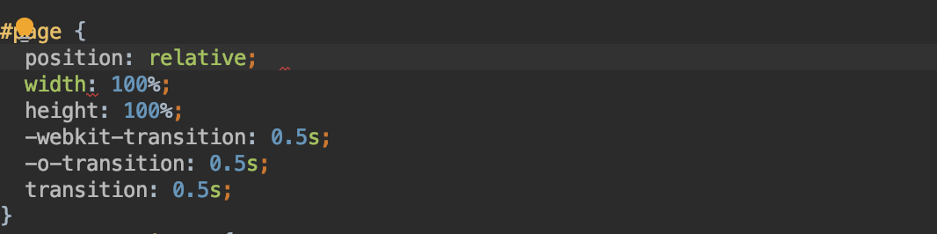

* + transition changes elements from one style to another effect.
  + transition: 0.5 s; Indicates that the time required for the gradient is 0.5s
  + -webkit-transition(Safari and Chrome) and-o-transition(Opera) make CSS3 effectively compatible with different browsers.

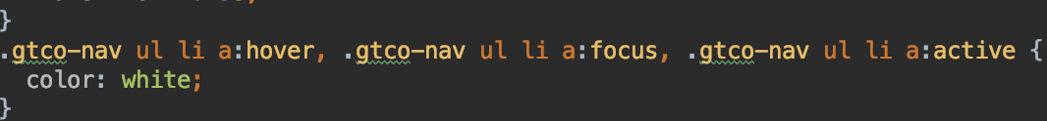

* + The nav bar is set to focus, and the text becomes white as the mouse move
  + Next, the web page distribution use the bootstrap framework.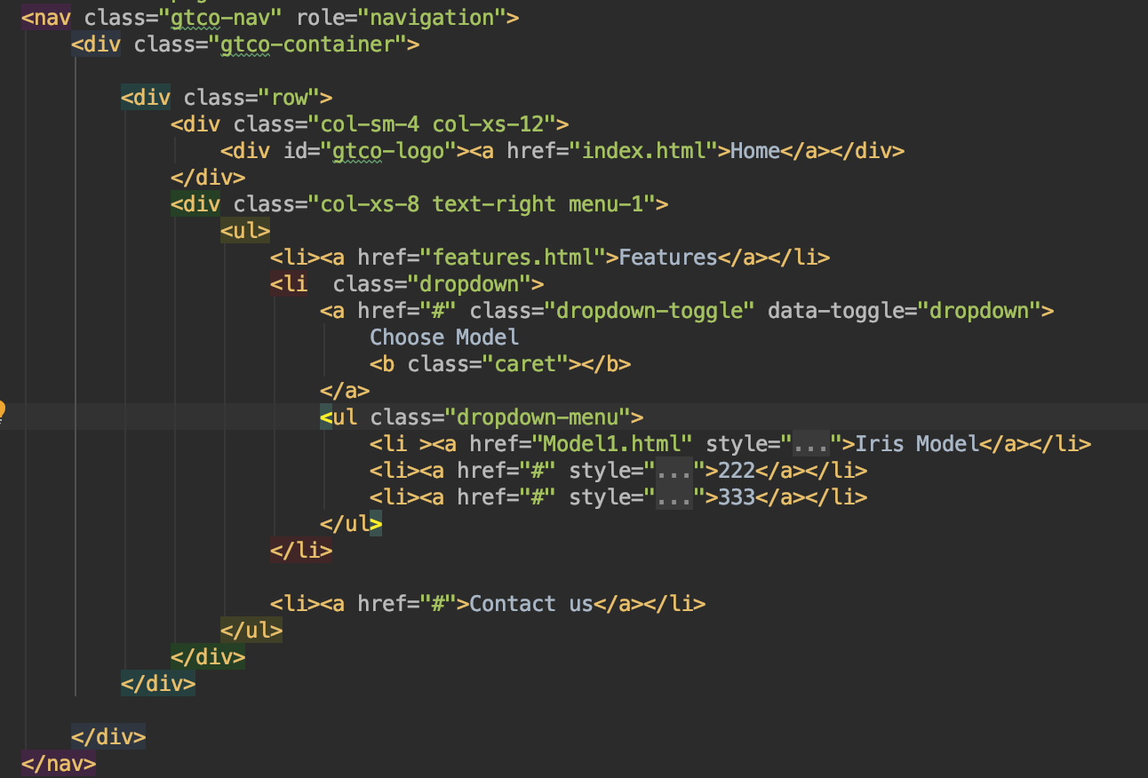
  + Adding role="navigation" to the <nav> tag helps increase accessibility.
  + data-toggle=“dropdown”,the dropdown menu references dropdown.js file.
  + Use bootstrap grid system distribute area for our web page



* + Use fadeOut() method, speed: fast, the page from visible to hidden in the process, make user to see a fade-out effect
* **Result:**

